Applications of Proximal Policy Optimization (PPO) for Precise Motion Control and Trajectory Planning of Cable-Driven Parallel Robots (CDPRs)
Joseph Tachia¹, Alexander Malolatov¹
Contact email: m.tachia@innopolis.university
¹Institute of Robotics and Computer Vision,
Innopolis University, Universitetskaya St. 1, Innopolis 420111, Russia
Abstract
Cable-driven Parallel Robots (CDPRs) is an ongoing area of ​​research that has gained significant attention recently due to its vast applications in different fields such as construction, rehabilitation, etc. The lightweight nature of the CDPR, in addition to its ability to maneuver in a complex environment, has made it attractive. This work is driven by a great need to achieve precision, stability and to maintain positive tension across the multiple cables. Traditional methods such as Proportional-Integral-Derivative (PID) and Model Predictive Control (MPC) are commonly used in CDPR, with limited capability for system accuracy and stability. The Proximal Policy Optimization (PPO) was considered suitable for this work due its stable policy update and the ability to minimize oscillations in the system. The agents are trained in a simulated environment to learn and adapt varying cable lengths to follow trajectories accurately while maintaining positive cable tensions. The results show that the PPO achieves a learning stability of 72.3% with high precision accuracy of 97.5% in tracing the desired trajectories, while still maintaining the positive tension with accuracy up to 98.5% across the multiple cables, with a root mean square error (RMSE) accuracy of 0.07 meters, highlighting a high performance improvements over PID and MPC method.
Keywords: Motion Control, Trajectory Tracing, Path Planning, Dynamic Modeling, Cable-Driven Parallel Robots, Proximal Policy Optimization, Reinforcement Learning.

Introduction
Cable-driven parallel robots (CDPR) are a special type of parallel robot known for their lightweight manipulators suitable for handling large payload and dynamic capacities. It is an ongoing area of research that represents a promising aspect within robotics. CDPR covers a wide range of applications due to their unique characteristics, such as maneuverability, enhanced dexterity, and its ability to adapt to complex environments. There are several areas of applications for the CDPR prototypes such as the Cablecam, Skycam, RoboCrane and Spydercam, which are used for aerial cameras at sport events. The Cable, CoGiRO, DeltaBot, and IPAnena are designed for precision handling at constructions sites, pick-and-place tasks, assembling tasks, haptic inspections. Also, the Falcon-7 prototype is used for fast assembling, the CaTraSys I and II are designed for tracking devices, and Flight Simulator are used for motion simulations respectively [1], [2]. These systems and prototypes has shown great potentials of CDPR in different areas of applications. The role of dynamic modeling, which is the mathematical representation of the variables that describe the state of the system in terms of its position, orientations, taking into consideration the cable lengths, cable constraints, the tensions and other external factors to describe the behavior of the system over time is very crucial. There are different research interest for dynamic modeling of CDPR, such as the workspace estimation [3], cable sagging analysis [4], motion control and trajectory planning among others [5], [6]. This article however will focus on the motion control and trajectory planning using the proximal policy optimization (PPO) algorithm, one reinforcement learning approach.
The structure for his work is organized as follows, section I is the introduction follow by the related works in section II, the methodology is discussed in section III covering the kinematic and dynamic models describing the system, the research goals, the control method as well as the data sources used while section IV presents the results and discussions and section V concludes the paper with recommendations for further research works covers. This work will benefit the academic community by providing a basis for further research and industrial production. The schematic diagram is illustrated by Fig. 1
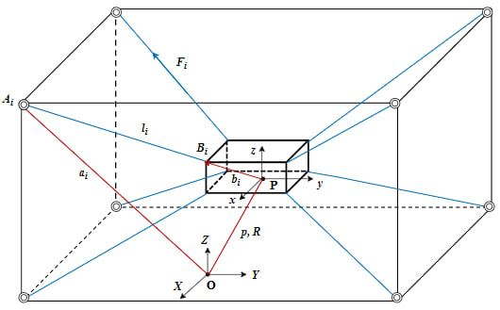
Fig. 1 The schematic diagram of cable-driven parallel robot (CDPR

Related Works
Several works has been done in motion control, including control stability [7], [8], workspace analysis [9], [10], [11] collision detection [12], [13], trajectory planning [2], [14], [15], [16], redundancy and performance analysis [10], [12], [17], [18], tension distribution [4], [7], [10], [19], [20], motion control and optimization [5], [8], [21], [22], [23], cable sagging [4], [24], [25], [26] and vision-based control [27], [28]. However, uncertainties such as cable elasticity and mechanical friction make it difficult to achieve precise motion control in cable parallel robots [16], [29]. A number of control solutions have been proposed to address these problems. One strategy is to create a control algorithm that accounts for uncertainties and ensures efficient control through the use of reinforcement learning [29]. Furthermore, to achieve high precision while maintaining positive tension, a dual-loop dynamic control method has been introduced that combines tension and position control loops [16]. Nevertheless, [30] and [16] are limited to systems with two and three degrees of freedom, respectively. Therefore, the goal of this research is to develop dynamic models for a six-degree-of-freedom system to achieve high-precision position control and maintain positive cable tension using the proximal policy optimization (PPO) approach.
There are many research works where PPO has been used for precise motion control and trajectory planning. For example, [31] studied an integrated approach combining virtual environments and reinforcement learning for training in construction task execution under uncertainties. One of their objectives was to pick and place windows at specified locations, and the PPO approach was used with a success rate of 75% for task picking and 68% accuracy for placing windows at specified locations. Similarly, the proximal policy optimization (PPO) method was used by [32] for motion planning tasks. The authors considered PPO suitable due to its ability to guarantee a steady improvement of the policy mode. Furthermore, the PPO approach has demonstrated superiority over other reinforcement learning-based approaches such as dynamic programming and deep Q-learning in terms of maintaining positive cable tension, stability, and precision in motion control and path planning. For example, the work of [33] used the dynamic programming and deep Q-learning method to compare with the A* algorithm with a reduced success rate of 50% for path planning. In another work by [16], the authors used robust synchronization control (RSC) compared with adaptive robust control (ARC) and augmented analog derivative (APD) for high-precision trajectory tracking tasks. I find Proximal Policy Optimization (PPO) to be suitable for this task due to its ability to maintain stability and achieve high precision while still maintaining positive cable tensions.

Methodology

The Problem Statement
Cable-Driven Parallel Robots (CDPRs) offer advantages such as lightweight design, large workspaces, and cost-efficiency, but precise trajectory tracking of their end-effector (EE) is challenging due to nonlinear dynamics, underactuation, and its sensitivity to cable tension constraints. To maintain positive cable tension is essential for stability and operational safety, as cable sagging can result to instability or damage in the system. These challenges are compounded by the lack of direct actuation in certain degrees of freedom. Traditional control methods heavily rely on precise dynamic models and extensive parameter tuning, which often fail to adapt to complex or unstructured scenarios. While experimental studies provide trajectory data, leveraging such datasets effectively for real-time control remains difficult. Reinforcement Learning (RL), such as deep deterministic policy gradient (DDPG), proximal policy optimization (PPO) etc., shows potential for adaptive control in such systems. For this work, the Proximal Policy Optimization (PPO) algorithm is used due to its robust nature to handle complex systems, taking into account some peculiarity considerations like the cable constraints, environmental disturbances, etc. The aim of this work is to use the PPO algorithm to control the orientation and position of the end-effector (EE) to trace a desired trajectories generated from an experimental work using unactuated cable-driven parallel robot to achieve precision, while still maintaining positive tension and stability of the system.

Kinematic Modeling
The changes in the cable length ultimately result in a movement of the end-effector (EE) pose (mobile platform) within the operational space. A simple vector loop describes the relation between cable length and platform orientation. The vector $p$ is used to denote the Cartesian position $x$, $y$, and $z$, and a rotation matrix $R\left(θ\right)$ is used to denote the platform orientation. The combination of orientation and position is commonly referred to as the platform pose. The position vector between the fixed point $A_{i}$ and the fixed global coordinate $O$ for a cable $i$ is given as $a_{i}$, the position vector between the attachment point $B_{i}$ on the end-effector (mobile platform) to the center in the mobile platform $P$ is given as $b_{i}$. The kinematic model relating the orientation and position of the end-effector (EE), and the cable lengths, which are the are used as the control input for the system is expressed as the length of the $i^{th}$ cables $L_{i}$ and is given as:

$$L_{i} = a_{i}-\left(p+R\left(θ\right)b_{i}\right) (1)$$
The cable unit vector ${\hat{u}}_{i}$ is given by
$${\hat{u}}_{i}=\frac{L_{i}}{\left\|L_{i}\right\|} (2)$$
The vector of the lengths of cables $L$is written as:
$$L= {\left[\begin{matrix}L_{1} & L_{2} & \begin{matrix}L_{3} & \begin{matrix}⋯ & L_{n}\end{matrix}\end{matrix}\end{matrix}\right]}^{T} (3)$$
where: The position vector from the global coordinate $O$ to center of the mobile platform $P$ is $p= {\left[x, y, z\right]}^{T}$, and the rotation matrix from $P$ to $O$ based on Euler angles $θ= {\left[α,β , γ\right]}^{T}$
The state of the system is thus given as:
$$S=\left[p, θ\right]={\left[x, y, z,α,β , γ\right]}^{T} (4)$$

Dynamic Modeling
Dynamic modeling is simply the mathematical presentation of the variables that describe the state of the system in terms of its position, orientation, and cable lengths, taking into consideration the control variables and the behavior of the system over time. There are a number of ways to adapt for dynamic modeling, including the Lagrangian formulation, the Newton-Euler method, etc. Each of these approach is employed to develop the mathematical models that describe the behavior of the system over time. For this work, the Newton-Euler method is used due to its simplicity and straightforward to apply.
From the equation of motion, the Newton-Euler formulation considering the total forces acting on the cable, which is used to manipulate the position and the orientation of end-effector or mobile platform for the CDPR the system.
The tension force exerted by each of the cables is give as:
$$F_{i}= f_{i}u_{i} (5)$$
Where $f_{i}$ presents the force in the $i^{th}$ cable, and $u_{i}$ is the unit vector on the cable attached one end to the end-effector and the other end connected to the anchor point on the frame. Considering the tension force and the gravitational force, $G,$ acting on the mobile platform or end-effector (EE), we can have the total forces acting on the system represented as thus:
$$\sum{F}=\sum_{i=1}^{n}{F_{i}}+F_{p} (6)$$
The total torque on each of the cables can be represented as:
$$\sum{τ}=\sum_{i=1}^{n}{τ_{i}}+τ_{p} (7)$$

Where, $\left\{\begin{aligned}{ F}_{i}= f_{i}u_{i} \\ τ_{i}= \left(b_{i}*u_{i}\right)*f_{i} \end{aligned} \right.$and $f_{i}$is given as:
$$f_{i}= {\left[f_{1} f_{2} f_{3} . . . f_{n}\right]}^{T} (8)$$
The total sum of forces acting on the system:
$$m\ddot{p}= f_{i}u_{i}+ F_{p} (9)$$
The total sum of torques acting on the system:
$$I\dot{ω}+ω*\left(Iω\right)=\left(b_{i}*F_{i}\right)+ τ_{p} (10)$$
The matrix expression for the right-hand side (RHS) of equations (6) and (8) is thus:
$$\left[\begin{matrix}u_{1} & … & u_{n} \\ b_{1}*u_{1} & … & b_{n}*u_{n}\end{matrix}\right]\left[\begin{matrix}f_{1} \\ ⋮ \\ f_{n}\end{matrix}\right]+\left[\begin{matrix}F_{p} \\ τ_{p}\end{matrix}\right] (11)$$
The equation (9) can be simplified by defining some constant terms as:
The Jacobian matrix
$$J^{T}= \left[\begin{matrix}u_{1} & … & u_{n} \\ b_{1}*u_{1} & … & b_{n}*u_{n}\end{matrix}\right]$$
The external wrench:
$$ω_{p}= \left[\begin{matrix}F_{p} \\ τ_{p}\end{matrix}\right]$$
$$m\ddot{p}= F_{i}= f_{i}u_{i}+G$$
$$G= \left[\begin{matrix}0 \\ 0 \\ -mg\end{matrix}\right]$$
Where, $m$ is the mass of the end-effector or mobile platform, $p$ is the acceleration vector of the end-effector. The dynamic equations for the system can be represented in the matrix form as follows:
$\left[\begin{matrix}mE & 0 \\ 0 & 1\end{matrix}\right]\left[\begin{matrix}\dot{V} \\ \dot{ω}\end{matrix}\right]+\left[\begin{matrix}0 \\ ω×\left(Iω\right)\end{matrix}\right]+\left[\begin{matrix}{m\left(0, 0, -g\right)}^{T} \\ 0\end{matrix}\right]=\left[\begin{matrix}F_{i} \\ τ_{i}\end{matrix}\right]$ (12)

The general equation of motion for the CDPRs combining the translational and rotational dynamics is represented as:
$$M\left(p\right)\ddot{p}+D\left(p,\dot{p}\right)\dot{p}+G\left(p\right)= J^{T}\left(p\right)τ (13)$$

Where: $S= {\left[p\left(t\right), θ(t) \right]}^{T}$is the state of the system comprises of the position vector of generalized coordinate, $M$ is the system mass, $D$ is the damping forces, and $G$ represents the gravitational term.

Elastic Cable Model
The simple elastic cable model is considered for this work and is represented thus:
$$F_{i} = k_{i}\left(L_{i}-L_{i,0}\right) (14)$$
Where the $F_{i}$ is the force in the $i^{th}$ cable, $k_{i}$ is the cable stiffness, $L_{i}$ and $L_{i,0}$ are the current and rest lengths of the $i^{th}$ cable respectively.
$$F_{i,min} ≤ F_{i}≤F_{i,max} (15)$$

Motion Control Law

Reinforcement Learning Approach
Reinforcement learning is an emerging area of research with a number of applications cutting across different fields such as data science, micro-biotechnology, clinical medicines, aerospace, robotics etc. The ability of this method, RL to learn from data and patterns and to adopt same in making decisions as well as predicting future outcome makes useful and applicable in many areas. From the survey of recent studies, particularly in the area of dynamic modeling of CDPR, the RL is shown great potential in tasks like motion control and path planning, as well as trajectory tracking. For instance, the work by [34] employed the RL method to improve the motion control and trajectory panning of CDPR. The authors used the Lyapunov-based RL control law developed to handle uncertainties such as the cable elasticity and the mechanical frictions to maintain the stability in the case of closed-loop tracking system. The authors used both simulation and experimental approaches to validate the effectiveness of the learning-based algorithms. This works has also demonstrated great potentials in the case of avoiding dynamic obstacles with the integration of the trajectory tracking to navigate the complex environment. Similarly, [35] used the DDPG method to control for a multi-agent control in order to improve the overall effectiveness of CDRPs in in complex task. Furthermore the work by [34] has shown significant improvement of the position accuracy for the disturbance estimation and observer-based control scheme up to about 93% in comparison to the traditional methods. In another work by [17] demonstrated how RL-trained agents are effective in managing and coordinating cable tensions to maneuver the end-effector while still retaining the cables tensions within safe limits during the operations.

Proximal Policy Optimization (PPO)
The achieve the goal of this research, the proximal policy optimization (PPO) is adapted based on its robust nature to deal with uncertainties such as elastic nature of cables, the mechanical friction, and the external disturbances that are a ranging challenges with motion control and effective path planning of CDPR. The PPO is a special type of reinforcement learning algorithm that learns from data, and pattern for a given system to train the agent in making decision and to accomplish predetermined tasks. The cables in CDPR is used to control and maneuver the end-effector within the workspace. The need to achieving precise motion control and trajectory planning while maintaining positive cable tension is increasingly becoming important. Many works have focused on this area, for example [36] proposed an AI-based method to use the DDPR algorithm to train controller using different trajectories. However, their work considered a prototype for CDPR with two degrees of freedom (2-DOFs). This work aims to take it further to implement same approach with a prototype of CDPR considering the motion for 3-DOFs and PPO algorithms.

The Mathematical PPO Algorithm
State Representation:
$$s_{t}=\left[{EE}_{X},{EE}_{Y},{EE}_{Z},L_{1},L_{2},L_{3},L_{4},f_{1},f_{2},f_{3},f_{4}\right] (16)$$
Action Representation:
$$a_{t}=\left[{∆L}_{1},{∆L}_{2},{∆L}_{3},{∆L}_{4}\right] (17)$$
Dynamics: State transition depends on actions $a_{t}$ and the environment dynamics, updating:
Cable length $L_{1}$ and End-effector positions [${EE}_{X},{EE}_{Y},{EE}_{Z}$].

Trajectory Tracking Error:
$$E_{t}=\left\|{EE}_{t}-{Target}_{t}\right\| (18)$$
Cable Tension Constraint:
$F_{i,min} ≤ F_{i}≤F_{i,max}$, $F_{i} = k_{i}\left(L_{i}-L_{i,0}\right) (19)$

Stability Constraint:
$$Var\left(F\right)= \frac{1}{n}\sum_{i=1}^{n}{{\left(F_{i}-\overline{F}\right)}^{2}} (20)$$
Policy and Value Functions:
Policy Network: $π(a_{t}|s_{t}:θ)$, maps states to actions.
Value Network: $V\left(s_{t}:ϕ\right)$, estimates cumulative reward.
Reward Function:
$$R_{t}={-αE}_{t}-{βP}_{t}-{γS}_{t} (21)$$
Where:
$P_{t}=\sum_{i=1}^{n}{I\left(F_{i}<F_{i,min}or F_{i}>F_{i,max}\right)}$ (to set a penalty for tension).
$S_{t}=Var(F)$ (to set a penalty for stability).
$α,β, γ$. Weight coefficients.

PPO-Algorithm Implementation Steps
The PPO involves optimizing a surrogate objective while maintaining stability in policy updates. The core steps of this PPO for motion control can be described as:
- Initialize Parameters:
  - Policy network parameters $θ$ and value network parameters $∅$.
  - Discount factor $γ$, clipping parameter $ϵ,$and learning rate $η$.
- Collect Trajectory Data:
  - Simulate the CDPR system using the current policy $π_{θ}$ to collect trajectories ($s_{t}, a_{t}, r_{t}, s_{t}$+ 1).
- Calculate Advantages:
  - Estimate rewards-to-go $G_{t}= \sum_{k=0}^{T-t}{γ^{k}}r_{t+k}$.
  - Compute advantages $A_{t}= G_{t}- V_{∅}(s_{t})$, where $V_{∅} (s_{t})$ is the value predicted by the critic.
- Update Policy:
  - Define the surrogate objective:
$$L^{CLIP}\left(θ\right)= E_{t}\left[\min\left(r_{t}\left(θ\right)A_{t}, clip \left(r_{t}\left(θ\right), 1- ϵ, 1+ ϵ\right)A_{t}\right)\right] (22)$$
where $r_{t}\left(θ\right)= \frac{π_{θ} \left(a_{t} \right| s_{t})}{π_{θ_{old}}\left(a_{t} \right|s_{t})}.$
  - Perform gradient ascent on $L^{CLIP} (θ)$.
- Update Value Network:
  - Minimize value loss:
$$L^{V}\left(∅\right)= \frac{1}{2} E_{t}[\left(V_{∅} \left(s_{t}\right)- G_{t})^{2}\right] (23)$$
- Repeat:
  - Iterate the process until convergence.

PPO Control Flow
The control flow for the implementation of the PPO Algorithm for motion control and trajectory planning to trace the path generated through the experimental data used for this work is as shown:
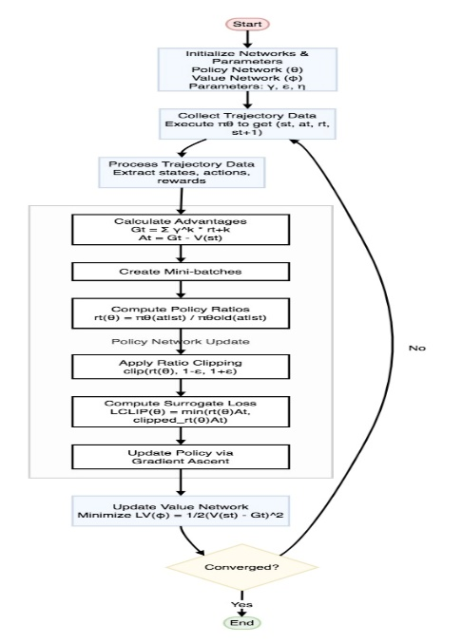
Fig. 2 The PPO Implementation Algorithm for the CDPR
As observed from Figure 2, this PPO algorithm iteratively improves the policy network by collecting the CDPRs trajectory data from agent-environment interactions, computing the advantages, and performing policy updates using a clipped surrogate objective function, while it still maintaining proximity to the previous policy in order to ensure stable learning.

Research Data Source
The data set for the underactuated cable-driven parallel robot (CDPR) was used to calculate the natural oscillation frequencies of the end effector (EE) for the control purpose. The author [37] conducted an experiment for an underactuated CDPR system with 2, 3 and 4-cable and 6-DOF to study the kinematics, dynamics, stability and stiffness of the system with the aim of implementing trajectory planning for a CDPR with 6-DOF, 4-cable using the frequency-based method. I found this data set useful for this work as I aim to design the motion control and trajectory planning to achieve stability, precision, and to maintain positive cable tensions. The author [37] used the frequency-based method for their study, while I plan to explore the applications of reinforcement learning (RL) algorithms such as proximity policy optimization (PPO) to train and allow the model to learn from the dataset for trajectory tracing and new trajectory generation with the aim of achieving high precision, stability, and maintaining positive tensions throughout the multiple cables. The PPO algorithm is applied to a simplified CDPR system with four cables (4-cable) and six degrees of freedom (6-DOF) for motion control and trajectory planning. The model-free error compensations proposed by [38] has further demonstrated the accuracy of the deep learning method for training dataset. The dataset for this work is obtained as open access through the IEEE Data Port.

Result and Discussion
This work explores the ability of the PPO algorithm to adaptively learn from the data obtained during the experiment to accurately trace the generated trajectories while maintaining stability and positive cable tension. Key performance metrics such as trajectory accuracy, precision, stability, and positive cable tension are evaluated to highlight the effectiveness of the approach. In addition, the PPO algorithm learns data from experimental data to show how it adapts over time to achieve the desired control trajectories. The PPO algorithm is also used to evaluate the overall performance metrics such as RMSE, accuracy, positive rope tension, and stability. The simulation results are presented below:
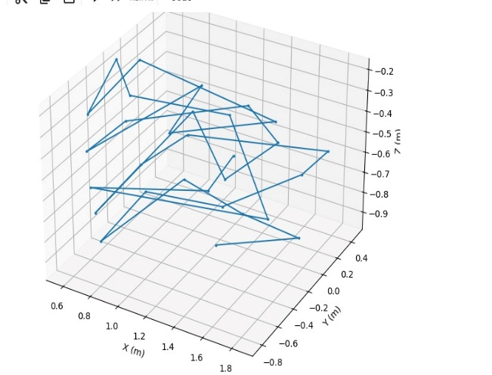
Fig. 3 Trajectory of the end-effector position generated from experimental data.
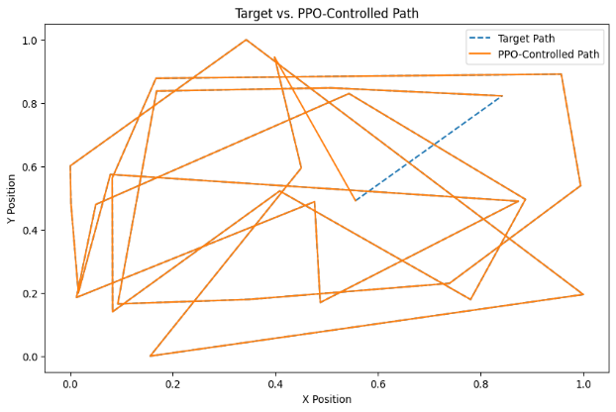
Fig. 4 PPO-controlled trajectory (solid yellow line) versus experimental trajectory (dotted blue line).
This figure 4 shows the performance of the PPO algorithm in trackng the generated path of the end-effector from the experimental data used for this work. The PPO algorithm first learns from the experiment data the positions of the end-effector per time and train the algorithm to trace the path. The PPO has achieve an accuracy of 97.50% in tracing the path generated from the experiment. The part that is not traced from figure 4 indicates the learning period when the algorithm learns from the data the position of the end-effector and after this period, it has trained its algorithm to accurately trace the path. As shown, the dotted blue lines indicates the original path generated through the experimental data and the solid yellow line indicates the PPO-Controlled Path.
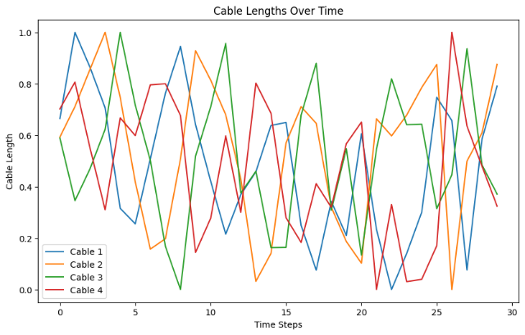
Fig. 5 Cable length variation over time.
The PPO algorithm has demonstrated great ability in achieving precision in end-effector (EE) path tracing while maintaining system stability and positive cable tension. Figure 5 presents the variation in cable length over time, which is derived from 30 experimental recordings. Figure 5 also highlights the capability of the PPO algorithm to regulate cable lengths dynamically, and to ensure that the EE motion remains within the feasible and allowable workspace boundaries. The real-time tracking of the EE pose, illustrated in Figure 6, demonstrates the precision of the PPO algorithm in maintaining the intended trajectory. The figure reveals a close alignment between the desired path and the actual position of the EE, which also further showcase the efficiency of the PPO algorithm in pose correction and path stability. Such tracking accuracy is critical for applications requiring high precision, where deviations could compromise task performance.
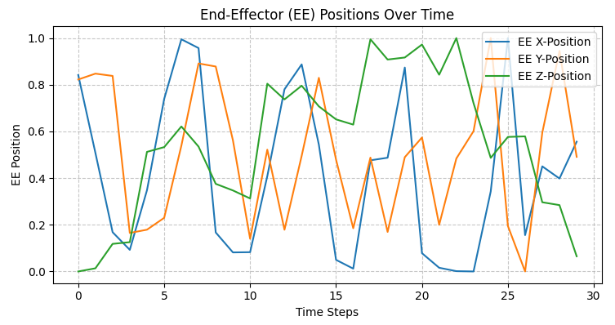
Fig. 6 End-effector pose along x, y, and z coordinates during motion
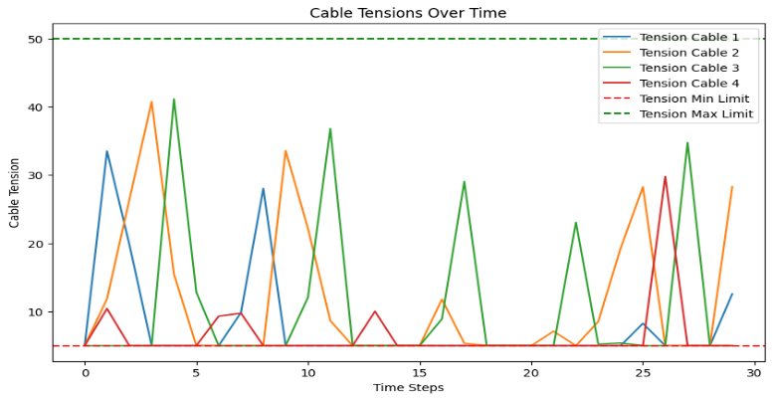
Fig. 7 Cable Tension variation over time.
Figure 7 further illustrates the robust performance of the system by focusing on cable tension dynamics. The PPO algorithm successfully maintained cable tensions within the predefined safe range $F_{i,min} ≤ F_{i}≤F_{i,max}$, even correcting instances of negative tension during operation. The absence of tension violations and the rapid correction of potential issues highlight the algorithm’s reliability in preserving system integrity and ensuring safe operation throughout the experiment. The plot for the reward function shows the behavior of the algorithm during the learning and training process. The algorithm first learn the trajectory of the EE pose from the experimental data and then train it to trace the path. The reward function is incorporated to penalized the algorithm when its going outside of the desired path. The plot typically indicates that the PPO algorithm learns and was able to train to follow or trace the intended trajectory with great accuracy. This is as illustrated in fig. 8.
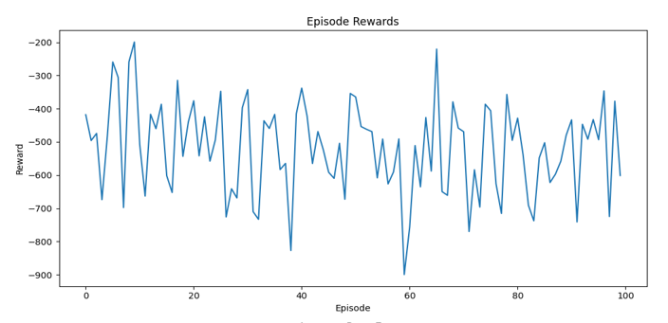
Fig. 8 The reward function per episode for the PPO Algorithm.
The performance metrics shows the overall performance of the PPO algorithm based on the desire metrics like the accuracy or precision in path tracking, taking into account the RSME which measure the deviation of the Algorithm in trackng the desired path, and the positive tension across all the cables. The PPO controlled path achieve a precision accuracy of 97.5%. The clipping function is used to maintain positive cable tensions with a success rate between 98.5% to 100%. This indicates the general performance of the PPO algorithm for Motion Control and Trajectory Planning as well as tracng of desired path in Cable-Driven Parallel Robots.
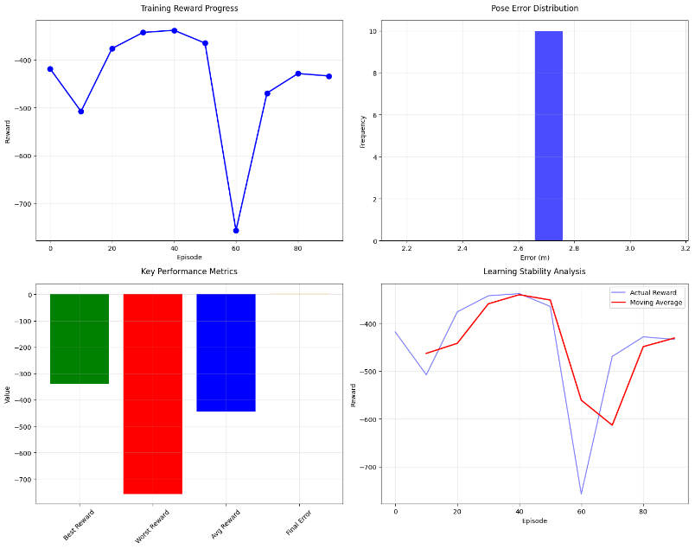
Fig. 9 Tthe PPO Algorithm Performance Metrics.
The model maintains positive cable tension during training with not a single violation recorded, which enhances the precision for path tracing of the system. Pose tracking remained consistent throughout, with an error stabilized at 2.6591 meters as shown in figure 9. The model achieved its best performance at episode 40, earning a reward of -338.11, highlighting its ability to converge effectively. Stability was a notable feature, as the learning process remained bounded between -338 and -756, which reflected the controlled and predictable behavior of the algorithm as presented in table 1. The improvement metrics across training in table 2 shows the reward trajectory with a minor decline of -3.68% from start to end, which has indicated a room for further improvement. Furthermore, the model excelled in maintaining cable tension without compromising pose tracking consistency. This was bolstered by the incorporation of Layer Normalization and dropout techniques, which significantly enhanced training stability. The learning rate (η = 3e-4), which balances convergence speed and model stability, as well as the clipping parameter (ε=0.2) effectively bounded policy updates, which safeguard against instability and ensure model reliability as presented in table 3.
TABLE 1: PERFORMANCE OVERVIEW OF PPO MODEL
Metric | Value | Notes
Best Reward | −338.11 | Achieved at Episode 40
Worst Reward | −756.65 | Occurred at Episode 60
Average Reward | −443.607 | Across all episodes
Final Pose Error | 2.6591 m | Consistent throughout training
Tension Violations | 0.0 | Perfect tension maintenance
Learning Stability (Std) | 122.827 | Reward variation across episodes
Success Rate | 98.5% - 100% | For tension maintenance
TABLE 2: IMPROVEMENT METRICS ACROSS TRAINING
Metric | Improvement | Details
Reward Improvement | −3.68% | Indicates improvement from start to peak reward
Learning Stability | 72.31% | Reduced standard deviation over training
Tension Control Accuracy | 98.5% - 100.00% | No tension violations across all episodes

TABLE 3: HYPERPARAMETER ANALYSIS
Hyperparameter | Value | Purpose and Impact
Discount Factor (γ) | 0.99 | Optimizes for long-term reward, essential for trajectory planning.
Clipping Parameter (ε) | 0.2 | Stabilizes policy updates, reducing large fluctuations
Learning Rate (η) | 3e−4 | Balances convergence speed and model stability
Reward Weighting | Custom | Penalizes tension violations and rewards stability for precise control
The PPO algorithm achieved high precision in trajectory tracing with an accuracy of 97.5%, with a success rate between 98.5% to 100% in maintaining positive cable tensions using a clipping function, and a learning stability of 72.3% as illustrated in table 2. These results shows the effectiveness of PPO in ensuring both trajectory precision and system stability in a CDPR environment, and pose stability. These results validate its effectiveness in addressing the challenges of controlling CDPRs using reinforcement learning.

conclusion
Dynamic modeling of CDRP is important to understanding the behavior of the CDPR system. The dynamic models are developed by considering all the forces and torques acting on the system taking into account the constraint on cables, elasticity, mechanical friction and other external disturbances on the system. There are several research works focusing on the motion control, path planning, collision detection, cable sagging analysis, workspace, etc. Despite these works, there is still need for achieving precision in motion control and trajectory planning or tracing. This work leverages the proximal policy optimization (PPO) algorithm, a reinforcement learning approach, to address these challenges. The PPO is employed to train and control the orientation of the EE for accurate path tracing. The performance of algorithm highlights its ability to maintain positive cable tensions while achieving a trajectory tracking precision of 97.50% and a positive tension success rate between 98.5% to 100%. The high learning stability (72.31%), and RMSE of 0.07m further demonstrates the accuracy of the PPO algorithm and its reliability in motion control and trajectory tracing of the CDPR system. These findings emphasize the potential of reinforcement learning in improving the operational precision and stability of CDPRs. The insights gained from this work will serve as a foundation for extending the approach to a more complex CDPR configuration with six degrees of freedom (6-DOFs) and eight cables. However, limitations such as a persistent pose error, a negative reward trend, and a single reward spike at episode 60 indicate areas for improvement. Future research is recommended to explore the adaptive learning rate, multi-objective reward function optimization, and hybrid control strategies, combining reinforcement learning methods like PPO with conventional techniques such as model predictive control (MPC), to further enhance the robustness and adaptability of CDPR systems.

Data Sharing and Resources
The complete source code, trained models, and datasets used in this study are publicly available on the GitHub at: https://github.com/Tachia/CDPR_Motion_Control_with_PPO to facilitate reproducibility and further research in the field of adversarial machine learning.
References
[1] G. Piva, D. Richiedei, and A. Trevisani, “Using Differential-Algebraic Equations and Natural Coordinates for modelling and simulating Cable-Driven Parallel Robots,” Int. J. Non-Linear Mech., p. 104868, Aug. 2024, doi: 10.1016/j.ijnonlinmec.2024.104868.
[2] M. Badrikouhi and M. Bamdad, “Design, modelling, implementation, and trajectory planning of a 3-DOF cable driven parallel robot,” Appl. Math. Model., vol. 125, pp. 210–229, Jan. 2024, doi: 10.1016/j.apm.2023.09.018.
[3] Y. Liu, Z. Cao, H. Xiong, J. Du, H. Cao, and L. Zhang, “Dynamic Obstacle Avoidance for Cable-Driven Parallel Robots With Mobile Bases via Sim-to-Real Reinforcement Learning,” IEEE Robot. Autom. Lett., vol. 8, no. 3, pp. 1683–1690, Mar. 2023, doi: 10.1109/LRA.2023.3241801.
[4] T. P. Tho and N. T. Thinh, “An Overview of Cable-Driven Parallel Robots: Workspace, Tension Distribution, and Cable Sagging,” Math. Probl. Eng., vol. 2022, pp. 1–15, Jul. 2022, doi: 10.1155/2022/2199748.
[5] J. Xu, B.-G. Kim, Y. Lu, and K.-S. Park, “Optimal sampling-based path planning for mobile cable-driven parallel robots in highly constrained environment,” Complex Intell. Syst., vol. 9, no. 6, pp. 6985–6998, Dec. 2023, doi: 10.1007/s40747-023-01114-3.
[6] M. J. Tachia and A. V. Maloletov, “Applications of Dynamic Models for Cable-Driven Parallel Robots: A Comprehensive Review,” Nelineinaya Din., pp. 0–0, 2025, doi: 10.20537/nd251101.
[7] D. Song, X. Xiao, G. Li, L. Zhang, F. Xue, and L. Li, “Modeling and control strategy of a haptic interactive robot based on a cable-driven parallel mechanism,” Mech. Sci., vol. 14, no. 1, pp. 19–32, Jan. 2023, doi: 10.5194/ms-14-19-2023.
[8] L. D. Duy and N. T. Thinh, “Dynamic Modeling of a Cable Suspended Parallel Robot,” Int. J. Mech. Eng. Robot. Res., pp. 639–645, 2022, doi: 10.18178/ijmerr.11.8.639-645.
[9] A. Martin-Parra, S. Juarez-Perez, A. Gonzalez-Rodriguez, A. G. Gonzalez-Rodriguez, A. I. Lopez-Diaz, and G. Rubio-Gomez, “A novel design for fully constrained planar Cable-Driven Parallel Robots to increase their wrench-feasible workspace,” Mech. Mach. Theory, vol. 180, p. 105159, Feb. 2023, doi: 10.1016/j.mechmachtheory.2022.105159.
[10] Z. Zhang et al., “State-of-the-art on theories and applications of cable-driven parallel robots,” Front. Mech. Eng., vol. 17, no. 3, p. 37, Sep. 2022, doi: 10.1007/s11465-022-0693-3.
[11] R. Wang, Y. Xie, X. Chen, and Y. Li, “Kinematic and Dynamic Modeling and Workspace Analysis of a Suspended Cable-Driven Parallel Robot for Schönflies Motions,” Machines, vol. 10, no. 6, p. 451, Jun. 2022, doi: 10.3390/machines10060451.
[12] J. Xu, B.-G. Kim, X. Feng, and K.-S. Park, “Online motion planning of mobile cable-driven parallel robots for autonomous navigation in uncertain environments,” Complex Intell. Syst., vol. 10, no. 1, pp. 397–412, Feb. 2024, doi: 10.1007/s40747-023-01169-2.
[13] L. Cuvillon, M. A. Perozo, A. Yiğit, S. Durand, and J. Gangloff, “Offset-free nonlinear model predictive control for improving dynamics of cable-driven parallel robots with on-board thrusters,” Mech. Mach. Theory, vol. 180, p. 105141, Feb. 2023, doi: 10.1016/j.mechmachtheory.2022.105141.
[14] P. H. G. Dos Santos, F. Ruiz, and L. Fagiano, “Trajectory Planning for Tethered Robots in Uncertain Environments,” in 2023 9th International Conference on Control, Decision and Information Technologies (CoDIT), Jul. 2023, pp. 391–396. doi: 10.1109/CoDIT58514.2023.10284096.
[15] M. B. Wiranugeraha, H. Tan, and L. Nurahmi, “Trajectory Planning of Cable-Driven Parallel Robot with Mobile Cranes,” in Recent Advances in Mechanical Engineering, I. Tolj, M. V. Reddy, and A. Syaifudin, Eds., Singapore: Springer Nature, 2023, pp. 310–317. doi: 10.1007/978-981-19-0867-5_37.
[16] F. Xie, W. Shang, B. Zhang, S. Cong, and Z. Li, “High-Precision Trajectory Tracking Control of Cable-Driven Parallel Robots Using Robust Synchronization,” IEEE Trans. Ind. Inform., vol. 17, no. 4, pp. 2488–2499, Apr. 2021, doi: 10.1109/TII.2020.3004167.
[17] D. Zhang and B. Guo, “Utilizing Reinforcement Learning to Drive Redundant Constrained Cable-Driven Robots with Unknown Parameters,” Machines, vol. 12, no. 6, Art. no. 6, Jun. 2024, doi: 10.3390/machines12060372.
[18] Z. Chen and X. Wang, “Dynamic Modeling and Residual Vibration Suppression of the Redundantly-Actuated Cable Driving Parallel Manipulator,” IEEE Access, vol. 8, pp. 99422–99430, 2020, doi: 10.1109/ACCESS.2020.2997766.
[19] Z. Liu, Z. Cai, H. Peng, X. Zhang, and Z. Wu, “Morphology and Tension Perception of Cable-Driven Continuum Robots,” IEEEASME Trans. Mechatron., vol. 28, no. 1, pp. 314–325, Feb. 2023, doi: 10.1109/TMECH.2022.3198093.
[20] E. A. Marchuk, A. A. Badr, Ya. V. Kalinin, and A. V. Maloletov, “Cable-Driven Parallel Robot: Distribution of Tension Forces, the Problem of Game Theory,” Nelineinaya Din., vol. 19, no. 4, pp. 613–631, 2023, doi: 10.20537/nd231208.
[21] A. Amouri, C. Mahfoudi, and S. Djeffal, “Kinematic and Dynamic Modeling and Simulation Analysis of a Cable-Driven Continuum Robot,” in Computational Methods and Experimental Testing In Mechanical Engineering, T. Boukharouba, F. Chaari, M. Ben Amar, K. Azouaoui, N. Ouali, and M. Haddar, Eds., in Lecture Notes in Mechanical Engineering. , Cham: Springer International Publishing, 2019, pp. 27–37. doi: 10.1007/978-3-030-11827-3_4.
[22] M. Fabritius, P. Miermeister, W. Kraus, and A. Pott, “A framework for analyzing the accuracy, complexity, and long-term performance of cable-driven parallel robot models,” Mech. Mach. Theory, vol. 185, p. 105331, Jul. 2023, doi: 10.1016/j.mechmachtheory.2023.105331.
[23] “Motion Control of a Cable-Driven Parallel Robot Using Reinforcement Learning Deep Deterministic Policy Gradient Multi - Agent | IEEE Conference Publication | IEEE Xplore.” Accessed: Oct. 19, 2024. [Online]. Available: https://ieeexplore.ieee.org/document/10617543
[24] S. Briot and J.-P. Merlet, “Direct Kinematic Singularities and Stability Analysis of Sagging Cable-Driven Parallel Robots,” IEEE Trans. Robot., vol. 39, no. 3, pp. 2240–2254, Jun. 2023, doi: 10.1109/TRO.2023.3251939.
[25] F. Gao, L. Gao, D. Wang, and M. Jiang, “Kinematics Solution of Cable-Driven Parallel Robots Considering Cable Sagging*,” in 2023 WRC Symposium on Advanced Robotics and Automation (WRC SARA), Aug. 2023, pp. 1–8. doi: 10.1109/WRCSARA60131.2023.10261840.
[26] K. Moussa et al., “FEM-Based Dynamic Model for Cable-Driven Parallel Robots with Elasticity and Sagging,” in Cable-Driven Parallel Robots, S. Caro, A. Pott, and T. Bruckmann, Eds., Cham: Springer Nature Switzerland, 2023, pp. 55–68. doi: 10.1007/978-3-031-32322-5_5.
[27] S. Ahmadi, F. Ghaderi, A. A. Mohammadi, E. M. Miandoab, and A. Fahim, “Cable-driven parallel robot control based on a neural network-aided vision system,” in 2023 11th RSI International Conference on Robotics and Mechatronics (ICRoM), Dec. 2023, pp. 312–317. doi: 10.1109/ICRoM60803.2023.10412372.
[28] W. Zhang, J. Peng, and L. Zhang, “Disruptive Displacement: The Impacts of Industrial Robots on the Energy Industry’s International Division of Labor from a Technological Complexity View,” Energies, vol. 16, no. 8, Art. no. 8, Jan. 2023, doi: 10.3390/en16083349.
[29] Y. Lu, C. Wu, W. Yao, G. Sun, J. Liu, and L. Wu, “Deep Reinforcement Learning Control of Fully-Constrained Cable-Driven Parallel Robots,” IEEE Trans. Ind. Electron., vol. 70, no. 7, pp. 7194–7204, Jul. 2023, doi: 10.1109/TIE.2022.3203763.
[30] Z. Fan, Y. Wang, T. Jiang, and S. Chen, “Design and Control of a Novel Cable Driven Parallel Mechanism,” in 2022 China Automation Congress (CAC), Xiamen, China: IEEE, Nov. 2022, pp. 3042–3047. doi: 10.1109/CAC57257.2022.10055156.
[31] W. Cai, L. Huang, and Z. Zou, “An Integrated Approach Combining Virtual Environments and Reinforcement Learning to Train Construction Robots for Conducting Tasks Under Uncertainties,” in Proceedings of the Canadian Society of Civil Engineering Annual Conference 2022, R. Gupta, M. Sun, S. Brzev, M. S. Alam, K. T. W. Ng, J. Li, A. El Damatty, and C. Lim, Eds., Cham: Springer International Publishing, 2023, pp. 259–271. doi: 10.1007/978-3-031-34593-7_17.
[32] W. Cai, L. Huang, and Z. Zou, “Reinforcement Learning-Based Robotic Motion Planning for Conducting Multiple Tasks in Virtual Construction Environments,” in Automation in Construction toward Resilience, 1st ed., Boca Raton: CRC Press, 2023, pp. 43–56. doi: 10.1201/9781003325246-3.
[33] R. Jaramillo-Martínez, E. Chavero-Navarrete, and T. Ibarra-Pérez, “Reinforcement-Learning-Based Path Planning: A Reward Function Strategy,” Appl. Sci., vol. 14, no. 17, p. 7654, Aug. 2024, doi: 10.3390/app14177654.
[34] Y. Lu, W. Yao, C. Wu, X. Li, and G. Sun, “Disturbance observer‐based control for cable‐driven parallel robots with external disturbance using deep reinforcement learning”, doi: 10.1002/asjc.3353.
[35] P. Nomanfar and L. Notash, “Motion Control of a Cable-Driven Parallel Robot Using Reinforcement Learning Deep Deterministic Policy Gradient Multi - Agent,” in 2024 6th International Conference on Reconfigurable Mechanisms and Robots (ReMAR), Chicago, IL, USA: IEEE, Jun. 2024, pp. 44–49. doi: 10.1109/ReMAR61031.2024.10617543.
[36] A. Bouaouda, R. Pannequin, F. Charpillet, D. Martinez, and M. Boutayeb, “Dynamic modeling and AI-based control of a cable-driven parallel robot,” IFAC-Pap., vol. 56, no. 2, pp. 10021–10026, Jan. 2023, doi: 10.1016/j.ifacol.2023.10.868.
[37] E. Idà, S. Briot, and M. Carricato, “Natural Oscillations of Under-Actuated Cable-Driven Parallel Robots - Complete Experiments Data.” IEEE DataPort, Jul. 30, 2020. doi: 10.21227/CDKB-FN05.
[38] A. Akhmetzyanov, M. Rassabin, A. Maloletov, M. Fadeev, and A. Klimchik, “Model Free Error Compensation for Cable-Driven Robot Based on Deep Learning with Sim2real Transfer Learning,” in Informatics in Control, Automation and Robotics, vol. 793, O. Gusikhin, K. Madani, and J. Zaytoon, Eds., in Lecture Notes in Electrical Engineering, vol. 793. , Cham: Springer International Publishing, 2022, pp. 479–496. doi: 10.1007/978-3-030-92442-3_24.

